

**Multi-Protocol on cDOT**

**Authors:** Ian Daniel

**Contributors:**  Craig Goettig

**Document Version:** V0.5

**Date:** August 2017

Status: Draft

**CONFIDENTIAL INFORMATION**

This document contains information proprietary to Thomson Reuters and may not be reproduced, disclosed or used in whole or part without express permission of Thomson Reuters.

© Thomson Reuters 2017

Contents

1 Introduction 4

1.1 Management Summary 4

1.2 Change History 4

1.3 Distribution List 5

1.4 Glossary 5

2 Multi-Protocol Configuration 6

2.1 Pre-requisites 6

2.2 Vserver and LIF creation 6

2.2.1 Create Vserver (replace hyphen with underscore in vserver rootvolume name) 6

2.2.2 Create LIF with default route and failover group 6

2.3 Volume creation 7

2.3.1 Create Volume 7

2.3.2 Set Volume Permissions to 777 7

2.3.3 Create export policies (repeat this step for each volume) 7

2.3.4 Create the default export-policy rule (repeat this command for every nfs client) 7

2.3.5 Create volume export policy rule (repeat this command for each volume and nfs client) 7

2.4 Qtree Creation 7

2.4.1 Create Qtree 7

2.4.2 Create Quota 7

2.4.3 Apply Quota 7

2.4.4 Set Qtree UNIX Permissions to 777 7

2.5 Primary job schedule and snapshot policy configuration 8

2.5.1 Create job schedule and snapshot policy: 8

2.5.2 Setup snap autodelete on volumes (run for each SNAP volume) 8

2.6 Add volumes to export & snapshot policies 8

2.7 DNS configuration 8

2.7.1 Setup DNS on a Vserver 8

2.8 Showmount script user 8

2.9 Create CIFS Server 8

2.10 CIFS Share Creation 9

2.10.1 Create Share 9

2.11 Default User Mapping 9

2.11.1 Create Default UNIX User Account and Group For Default Mapping 9

2.11.2 Create Default CIFS Default User Mapping 9

2.11.3 Create Default NFS Default User Mapping 9

2.12 User Mapping Rules 9

2.12.1 Create User Account and Group For Mapping 9

2.12.2 Create CIFS User Mapping Rules 9

2.12.3 Create NFS User Mapping Rules 9

2.13 QoS policy group creation 10

2.13.1 Create QoS policy group per volume and apply 10

2.14 Cluster and Vserver Peering 10

2.14.1 Confirm that cluster peering has been enabled 10

2.14.2 Create the cluster peer (skip this step if cluster peering has been configured) 10

2.14.3 Confirm if vserver peering has been configured 10

2.14.4 Create vserver peering on the destination system (skip this step if vserver peering has been configured) 10

2.14.5 Accept the vserver peering on the source system 10

2.15 SnapVault configuration 10

2.15.1 Create secondary volumes for SnapVault as type “DP” on the destination cluster 10

2.15.2 Create a cron job schedule if it does not exist in the destination 10

2.15.3 Configure a snapmirror policy on the destination 11

2.15.1 Initialize SnapVault relationship on the destination 11

3 Diagnosing Multi-Protocol Issues 12

3.1 User Mapping 12

3.1.1 Check AD name resolution: 12

3.1.2 Check Unix name resolution: 12

3.1.3 Check Windows to Unix mapping: 12

3.1.4 Check Windows to Unix mapping: 12

# Introduction

## Management Summary

This document details the process used to configure multi-protocol access in cDOT. At this time the solution mirrors the current standards used for 7-Mode.

The diagram below shows an overview of the current cDOT architecture.

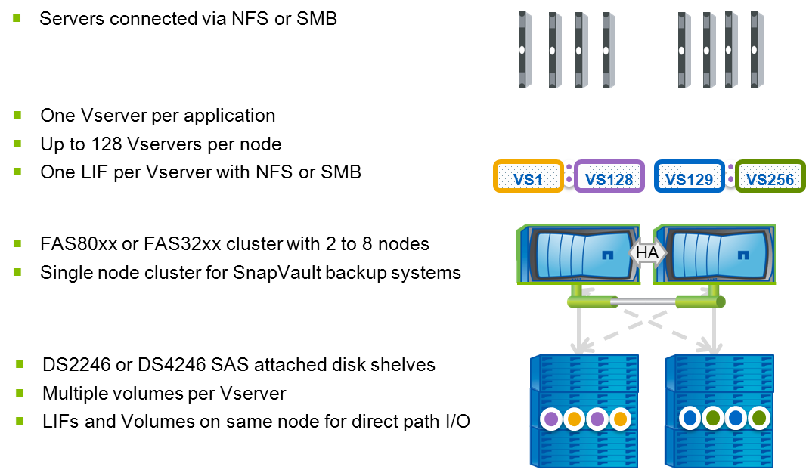

## Change History

|  |  |  |  |
| --- | --- | --- | --- |
| **Ver** | **Date** | **Author** | **Key Changes** |
| 0.1 | February 2016 | Ian Daniel | Initial Version |
| 0.2 | March 2016 | Ian Daniel | Added section on mapping users |
| 0.3 | March 2016 | Ian Daniel | Fixed typo |
| 0.4 | March 2016 | Ian Daniel | Added diagnostic commands |
| 0.5 | August 2017 | Ian Daniel | Modified default export policy |
|  |  |  |  |
|  |  |  |  |
|  |  |  |  |
|  |  |  |  |
|  |  |  |  |

## Distribution List

|  |  |
| --- | --- |
| **Name** | **Role** |
| Storage Engineering | Reviewer |
| Storage Delivery | Reviewer |
| Storage Architecture | Reviewer |

## Glossary

|  |  |
| --- | --- |
| **Term** | **Definition** |
| cDOT | clustered Data ONTAP |
| Vserver | A logical storage virtual server, also known as a Storage Virtual Machine (SVM), which contains LIFs, Volumes, and configuration information such as access control details. |
| LIF | Logical Interface – a cDOT logical network interface with an IP address, assigned to a single Vserver. |
| CIFS | Short for Common Internet File System, a protocol that defines a standard for remote file access using millions of computers at a time. With CIFS, users with different platforms and computers can share files without having to install new software. |
| SMB | Short for Server Message Block, a message format used by DOS and Windows to share files, directories and devices. |
| NFS | A distributed file system protocol originally developed by Sun Microsystems in 1984, allowing a user on a client computer to access files over a computer network much like local storage is accessed. |

# Multi-Protocol Configuration

## Pre-requisites

* Confirm the target aggregate has sufficient capacity
* Confirm the target cluster has an NFS license
* Confirm the target cluster has an CIFS license
* Confirm there is network connectivity between the client and the cluster.
* Make a note of the required CIFS Domain.
* Make a note of required DNS servers.
* Ensure you have an account with permissions to add the vserver to the required domain.
* Ensure that the cDOT AV solution is available and active for the cluster you are creating a multi-protocol vserver on.

## ****Vserver and LIF creation****

### Create Vserver (replace hyphen with underscore in vserver rootvolume name)

vserver create -vserver <vsname> -rootvolume <vsname>_root -aggregate <aggrname> -ns-switch file -nm-switch file -rootvolume-security-style unix -language <language>

vserver show

**Note:** vserver language is inherited by volumes and should be set to en_US

### Create LIF with default route and failover group

network interface create -vserver <vsname> -lif <vsname>-lif-<lif#> -role data -data-protocol nfs,cifs -home-node <node> -home-port <port> -address <ip> -netmask <netmask> -status-admin up -firewall-policy mgmt -failover-group <group>

network routing-groups route create -vserver <vsname> -routing-group d<network>/<mask> -destination 0.0.0.0/0 -gateway <gateway>

vserver show

network interface show

network interface show -failover

network routing-groups route show –vserver <vsname>

## ****Volume creation****

### Create Volume

volume create -vserver <vserver> -volume <volume_name> -aggregate <aggregate_name> -size <size_of_volume> -junction-path /<volume_name>

volume mount -vserver <vserver> -volume <volume_name> -junction-path /<volume_name>

volume show -vserver <vserver> -junction

### Set Volume Permissions to 777

vol modify -vserver <vserver> -volume <volume_name> -unix-permissions 777

### Create export policies (repeat this step for each volume)

vserver export-policy create –vserver <vsname> –policyname <volume_name>

### Create the default export-policy rule (repeat this command for every nfs client)

vserver export-policy rule create -vserver <vsname> -policyname default -clientmatch <nfsclient> -rorule sys -rwrule never -superuser never

### Create volume export policy rule (repeat this command for each volume and nfs client)

vserver export-policy rule create -vserver <vsname> -policyname <volume_name> -clientmatch <nfsclient> -rorule sys -rwrule sys -superuser sys -protocol nfs3

## ****Qtree Creation****

### ****Create Qtree****

volume qtree create -vserver <vsname> -volume <volume_name> -qtree <qtree> -security-style unix

### ****Create Quota****

volume quota policy rule create -vserver <vsname> -policy-name default -volume <volume_name> -type tree -target <qtree> -disk-limit <quota_limit>

### ****Apply Quota****

volume quota on -vserver <vsname> -volume <volume_name>

### ****Set Qtree UNIX Permissions to 777****

qtree modify -vserver <vsname> -volume <volume_name> -qtree <qtree> -unix-permissions 777

## ****Primary job schedule and snapshot policy configuration****

### Create job schedule and snapshot policy:

job schedule cron create -name <volume_name> -minute <min> -hour <hour>

volume snapshot policy create -vserver <vsname> -policy <volume_name> -enabled true -schedule1 <volume_name> -count1 7 -snapmirror-label1 snapvault -prefix1 sv_<volume_name>

job schedule cron show -name <vol_name>

volume snapshot policy show –vserver <vsname>

### Setup snap autodelete on volumes (run for each SNAP volume)

volume modify -vserver <vsname> -volume <volname> -space-mgmt-try-first snap_delete

volume snapshot autodelete modify -vserver <vsname> -volume <vol_name> -enabled true

volume snapshot autodelete modify -vserver <vsname> -volume <vol_name> -trigger snap_reserve

volume show -vserver <vsname> -fields space-mgmt-try-first

volume snapshot autodelete show -vserver <vsname>

## Add volumes to export & snapshot policies

volume modify -volume <volume_name> -policy <volume_name> -snapshot-policy <volume_name> -vserver <vserver>

## ****DNS configuration****

### Setup DNS on a Vserver

vserver services dns create -vserver <vsname> -domains <domainname> -name-servers <comma_separate_name_server_list>

vserver services dns show

## Showmount script user

security login role create -role showmount -cmddirname "vserver export-policy" -access readonly -vserver <vserver>

security login role create -role showmount -cmddirname volume -access readonly -vserver <vserver>

security login role create -role showmount -cmddirname "version" -access all -vserver <vsname>

security login create -username shwmnt -application ontapi -authmethod password -role showmount -vserver <vserver>

## ****Create CIFS Server****

cifs server create -vserver <vsname> -cifs-server <vsname> -domain -ou ou=<OU>,ou=<OU>,ou=<OU>

## ****CIFS Share Creation****

### ****Create Share****

cifs share create -share-name <share_name> -path <Path_To_Data> -vserver <vsname>

## ****Default User Mapping****

User mapping can be used in two different ways to enable file permissions to be set as required. These consist of either setting a single default user/group for UNIX🡪Windows and Windows🡪UNIX or the addition of mapping rules and UNIX users to facilitate a more detailed level of user mapping. The UID and GID used on the vserver must correspond to the user on the UNIX server.

### ****Create Default UNIX User Account and Group For Default Mapping****

unix-user create -vserver si-8040-test-02 -user <UNIX_User> -id <UID> -primary-gid <GID>

unix-group create -vserver si-8040-test-02 -name helpdesk -id <GID>

### ****Create Default CIFS Default User Mapping****

cifs options modify -vserver <vsname> -default-unix-user <UNIX_User>

### ****Create Default NFS Default User Mapping****

vserver nfs modify -vserver <vsname> -default-win-user <DOMAIN\\Username>

## ****User Mapping Rules****

With the addition of mapping rules and UNIX users we can facilitate a more detailed level of user mapping as opposed to the 1-1 mapping you get by just setting default users. By default a users domain login will map to a UNIX login that matches i.e. ten\uc123456 will map to uc123456. There must be a matching UNIX user setup on the cDOT vserver for this to work.The UID and GID used on the vserver must correspond to the user on the UNIX server.

### ****Create User Account and Group For Mapping****

unix-user create -vserver <vsname> -user <UNIX_User> -id <UID> -primary-gid <GID>

unix-group create -vserver <vsname> -name helpdesk -id <GID>

### ****Create CIFS User Mapping Rules****

This rule will match any TEN domain user and map the user portion to a UNIX user configured on the vserver i.e. TEN\uc123456 🡪 c123456 (note it is NOT case sensitive)

vserver name-mapping create -vserver <vsname> -direction win-unix -position 2 -pattern ten\\(.)(.+) -replacement \2

### ****Create NFS User Mapping Rules****

This rule will match any UNIX user configured on the vserver and map the user portion to a CIFS TEN user i.e. c123456 🡪 TEN\uc123456

vserver name-mapping create -vserver <vsname> -direction unix-win -position 1 -pattern (.+) -replacement TEN\\\u\1

## ****QoS policy group creation****

### Create QoS policy group per volume and apply

qos policy-group create -policy-group <volname> -vserver <vsname> -max-throughput 6000iops

volume modify -vserver <vsname> -volume <volume> -qos-policy-group <volname>

qos policy-group show

volume show –vserver <vsname> -fields qos-policy-groupSnapvault Configuration

## Cluster and Vserver Peering

### Confirm that cluster peering has been enabled

cluster peer show

### Create the cluster peer (skip this step if cluster peering has been configured)

cluster peer create -peer-addrs <remote_ICL_IP1,remote_ICL_IP2> -username admin

cluster peer show

### Confirm if vserver peering has been configured

vserver peer show

### Create vserver peering on the destination system (skip this step if vserver peering has been configured)

vserver peer create -vserver <destination_vserver> -peer-cluster <source_cluster> -peer-vserver <source_vserver> -applications snapmirror

vserver peer show

### Accept the vserver peering on the source system

vserver peer accept -vserver <source_vserver> -peer-vserver <destination_vserver>

vserver peer show

## SnapVault configuration

### Create secondary volumes for SnapVault as type “DP” on the destination cluster

volume create -vserver <vserver> -volume <volume_name> -aggregate <aggr_name> -size <size> -security-style unix -space-guarantee none -percent-snapshot-space 0 -language <vol_language> -type DP

volume show

### Create a cron job schedule if it does not exist in the destination

job schedule cron create -name xdp_<hour> -minute 00 -hour <hour>

job schedule show

### Configure a snapmirror policy on the destination

* **7 day retention will have a snapshot count of 7 on the secondary**
* **14 day retention will have a snapshot count of 14 on the secondary**
* **30 day retention will have a snapshot count of 30 on the secondary**
* **45 day retention will have a snapshot count of 45 on the secondary**

snapmirror policy create -vserver <vserver> -policy <volume>

snapmirror policy add-rule -vserver <vserver> -policy <volume> -snapmirror-label snapvault -keep <retention#>

snapmirror show -destination-path * -fields Schedule

snapmirror policy show

### Initialize SnapVault relationship on the destination

snapmirror create -source-path <source_vserver>:<source_volume> -destination-path <destination_vserver>:<destination_volume> -type XDP -schedule <schedule_name> -policy <policy_name>

snapmirror initialize -destination-path <destination_vserver>:<destination_volume>

snapmirror show

# Diagnosing Multi-Protocol Issues

There are a number of useful commands for diagnosing issues with Multiprotocol shares, the main ones are summarized below. You need to be at diag privilege for these commands to be available.

## User Mapping

### Check AD name resolution:

diag secd authentication translate –node <node> -vserver <vserver> -win-name <username>

**Example**

eg-si-clsn-e01::*> diag secd authentication translate -node eg-si-clsn-e01-h01 -vserver si-8040-test-02 -win-name ten\uc136758

S-1-5-21-2012327785-2259879848-3711903672-181740

### Check Unix name resolution:

diag secd authentication translate –node <node> -vserver <vserver> -unix-user-name <username>

**Example**

eg-si-clsn-e01::*> diag secd authentication translate -node eg-si-clsn-e01-h01 -vserver si-8040-test-02 -unix-user-name c136758

1234567

### Check Windows to Unix mapping:

diag secd name-mapping show –node <node> -vserver <vserver> -direction win-unix <username>

**Example**

eg-si-clsn-e01::*> diag secd name-mapping show -node eg-si-clsn-e01-h02 -vserver si-8040-test-02 -direction win-unix -name ten\uc136758

ten\uc136758 maps to c136758

### Check Windows to Unix mapping:

diag secd name-mapping show –node <node> -vserver <vserver> -direction unix-win <username>

**Example**

eg-si-clsn-e01::*> diag secd name-mapping show -node eg-si-clsn-e01-h02 -vserver si-8040-test-02 -direction unix-win -name c136758

c136758 maps to ten\uc136758